### Details of the functionality and features

### 

Figure 1 : Student login page to access study notes

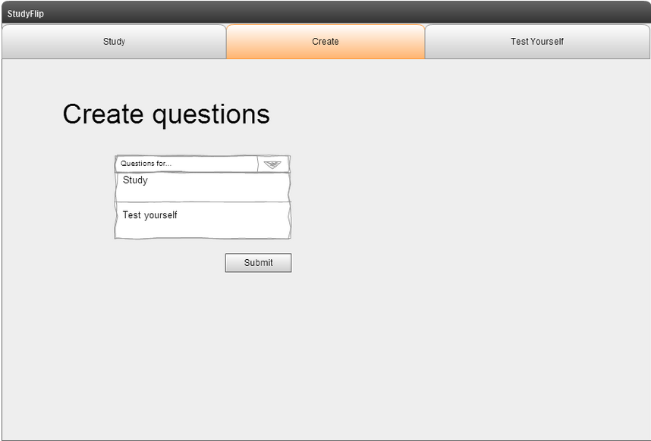

Figure 2: Student create questions page. Study or Test Yourself

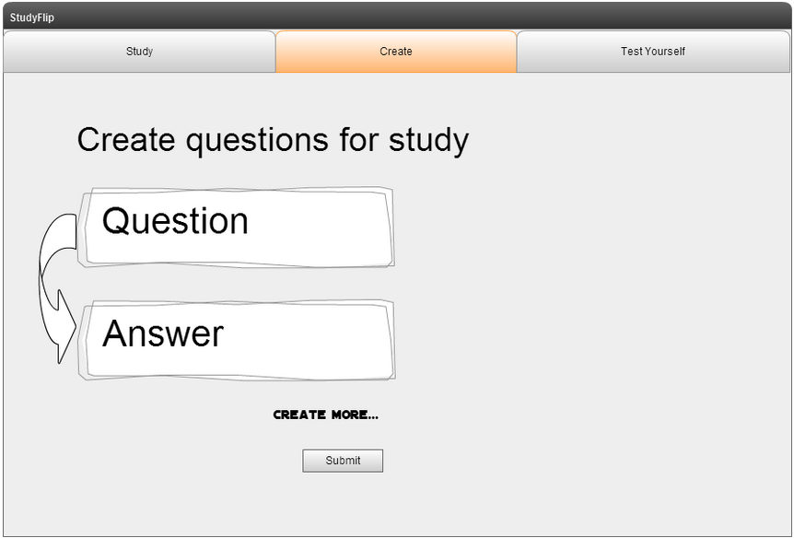

Figure 3: Student creates questions for study

### 

Figure 4: After creating study questions, student clicks on study tab and presented topic selection

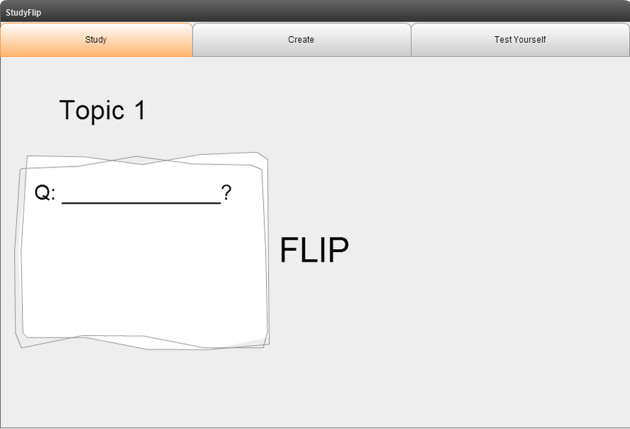

Figure 5: Student is presented the first question

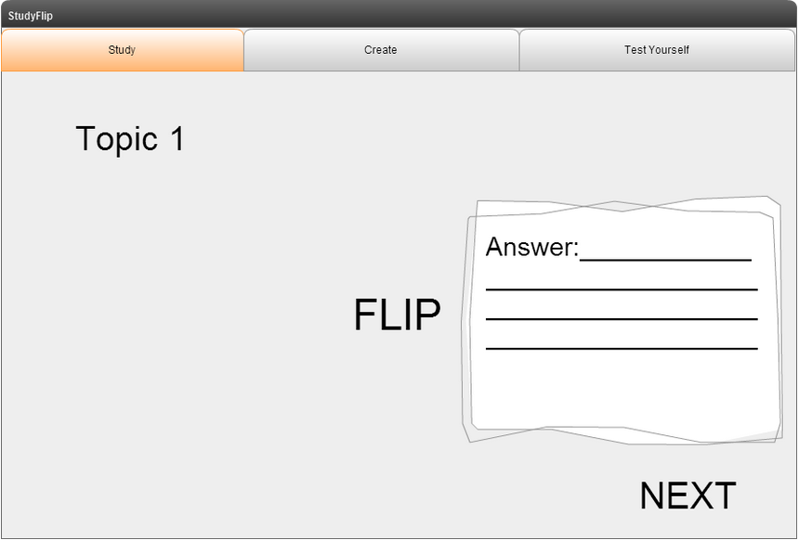

Figure 6: Student clicks flip and is shown the answer. Student then looks at the answer and clicks next when finished

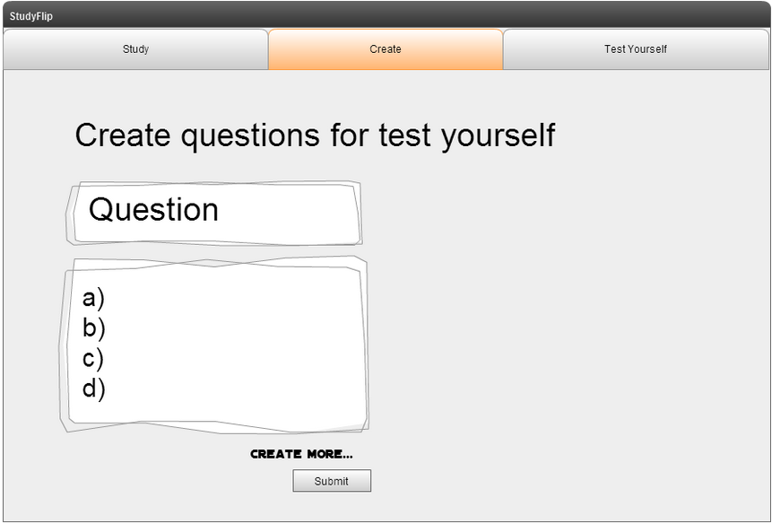

Figure 7: Student clicks create questions and enters questions and multiple choice answers

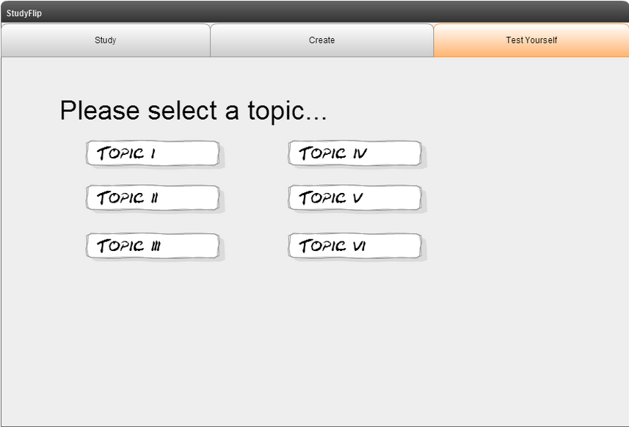

Figure 8: After creating a test yourself topic, user clicks on test yourself and is presented the topic selection page

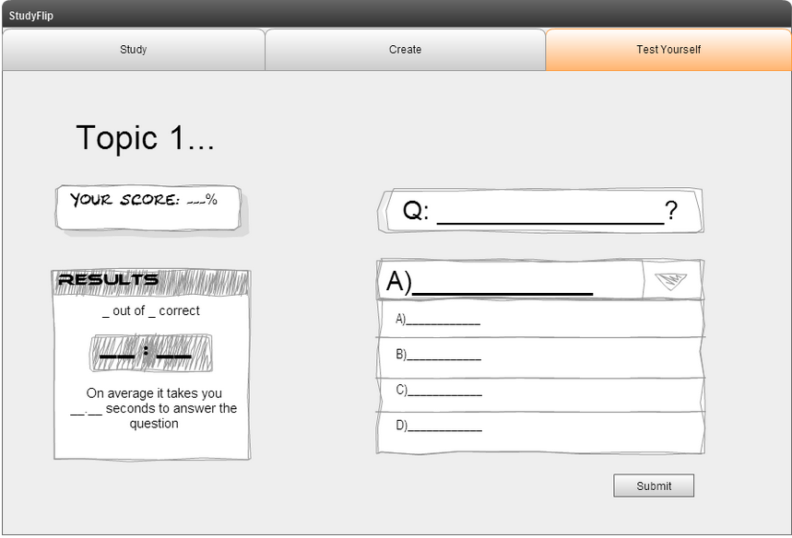

Figure 9: Once test starts, timer can be shown with questions and multiple choice answers. A submit box is present underneath

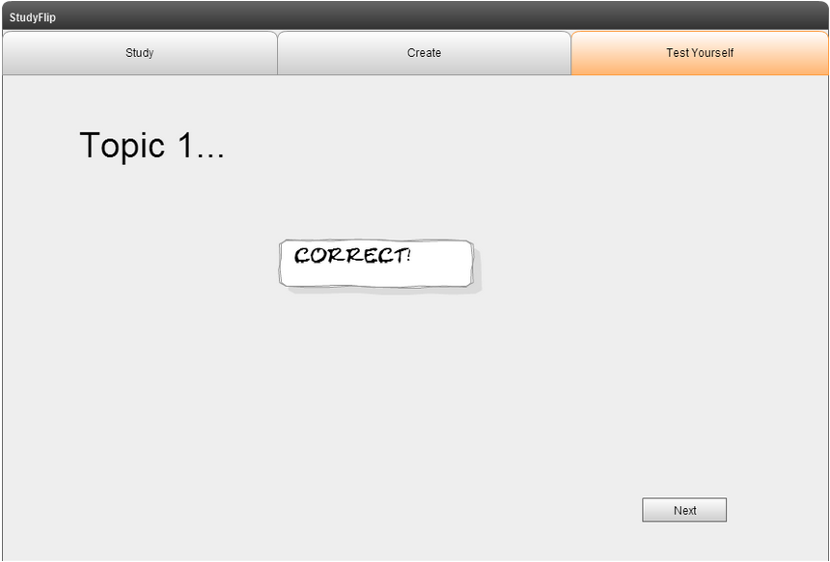

Figure 10: User gets question correct

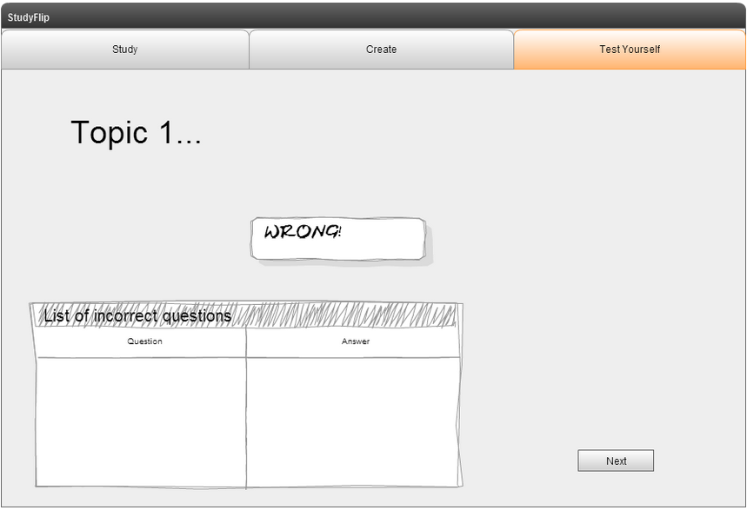

Figure 11: User gets question wrong, wrong questions and answers go into incorrect questions bank